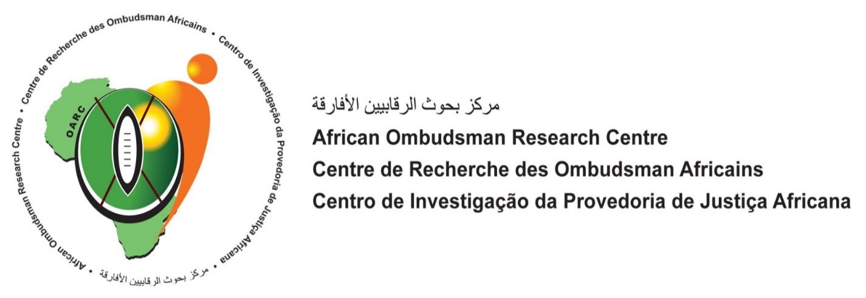
Working Concept Note and Agenda for Regional Training
6th – 8th March, Djibouti

The African Ombudsman Research Centre (AORC) was established in 2011 as the research and training arm of the African Ombudsman and Mediators’ Association. AORC is mandated to promote capacity development, knowledge generation and professionalism within African Ombudsman institutions in furtherance of good governance, the rule of law, and human rights. AORC provides practical regional and tailored training to Ombudsman Offices on topics such as Ombudsman principles and evolution, case handling, investigation skills and mediation.

Training Theme: The Role of the Ombudsman in promoting human rights and peace
The upcoming 3 (three) day training for Ombudsman and senior staff in the North African and East African regions will focus on the practical measures that Ombudsman can take to promote and protect the human rights of vulnerable populations, especially persons subject to the challenges arising from migration, internal displacement, sexual violence and slavery.

Training Goal: Each Ombudsman will commit to take some measurable action over the next
year to implement tools or strategies they have learned.

Training Method: Each facilitator will incorporate a mix of presentations and opportunities for
participants to delve into and share their thinking on the issues and information presented.

Participants: North and East African regions
AORC has invited approximately 28 Ombudsman and senior staff to participate. There will be simultaneous translation: French / Arabic / English

Research: AORC collaboration with the International Ombudsman Institute
In addition to the training, AORC will be conducting intensive evening interviews with up to nine of the remaining countries that must be interviewed for the comprehensive Africa-wide study of the 44 national Ombudsman throughout Africa.

Working Agenda: The Role Of The Ombudsman In Promoting Human Rights And Peace

Monday 5th March:
All day Participants arrive

13:00 Facilitators lunch, Sheraton Hotel: meet / discuss approaches, alignment of themes

15:30 – 17:30: Research interview – Burundi

19:30 Informal Travelers Welcome – light cocktail food

Tuesday 6th March

8:45 Official opening / welcome: Ombudsman for Djibouti, H.E. Dr Kassim Issak Ousman

10:00 Adv. A. Brock, Director, AORC

Introduction to Training and Theme
Evolution of the Ombudsman – Confluence of Human Rights and Administrative Justice

10:45 tea break

11:00 Participants discuss in small groups: human rights provisions in their mandates and/or current use of human rights principles in their work

11:45 Plenary: each group shares deliberations

13:00 lunch

14:00 Hon. Edouard Nduwimana, Ombudsman for Burundi

Practical Implications for Ombudsman: Human Rights and Peace
  - UN encouragement of role for the Ombudsman
  - Causes of insecurity, refugee conditions and internal displacement
  - The example of Burundi – law and practice

15:30 Plenary: participants share reflections on how their mandates and offices can contribute to peace as needed in their countries

16:15 tea / end of day

16:30 Research interviews – Egypt; Libya; Rwanda (confirm with Dr. Annie Devenish)

19:30 Dinner hosted by AORC at Sheraton Hotel

Wednesday 7th March

9:00 Aliro Omara, Human Rights Centre, Uganda

Protection and Promotion of the Rights of Refugees and Internally Displaced Persons:
  - Definition and Context
  - International and Regional Framework for Protection of Refugees

10:15 tea break

10:30 Overview of Instruments, Rights and Standards for Protection of Internally Displaced Persons

11:15 Role of National Human Rights Institutions in the Protection of Refugees and Internally Displaced Persons Aliro Omara, Human Rights Centre, Uganda

12:30 lunch

13:30 Participants discuss in small groups situation of Refugees and IDPs in their countries and applicability of standards reviewed in morning

14:15 Plenary discussion, facilitated by Aliro Omara: participants share information and reflections

14:45 Ambassador Mussie Haile, Regional Director, United Religions International – Africa

The working partnership between African Ombudsman & Religious Leaders to promote peaceful coexistence, human dignity and to prevent violent extremism and hate speech in Africa:

15:30 Plenary: participants share reflections on afternoon themes

16:00 tea / end of day

16:30 Research interviews – Mauretania; Somalia; Tanzania; Tunisia (confirm with Dr. Annie Devenish)

Participants are on their own for dinner and/or visits with local friends and/or rest

Facilitators join AORC for dinner if you do not have other plans.
Thursday 8th March

9:00 Steve Onwuasoanya, Commonwealth Secretariat

Vulnerability of women and girls as Refugees or IDPs

10:30 Participants discuss strategies for collaboration and interventions for women and girls

11:15 tea break

Special Issues for Northern Africa
11:30 Daher Osman Karie, Djibouti

12:00 [Tarek Ramadan M Allaghi, Office of the Ombudsman for Libya]

12:30 Ombudsman for Sudan Judge Ahmed Abuzaid Ahmed

13:00 lunch

14:00 Panel: facilitated by Adv. Brock
- Dr Kassim Issak Ousman, Mediator for Djibouti
- Hon. Edouard Nduwimana, Ombudsman for Burundi
- Aliro Omara, Human Rights Centre, Uganda
- Steve Onwuasoanya, Commonwealth Secretariat, UK
- Amb. Mussie Haile, United Religions International – Africa

15:00 Commitments: Participants articulate specific commitments gained from training

16:00 End of training: Comments: Host Ombudsman, Mediator Ousman and Adv. Brock

16:30 Research interviews: Morocco; Sudan (confirm with Dr. Annie Devenish)

19:30 Dinner hosted by Dr Kassim Issak Ousman, Mediator for Djibouti

Friday 9th March:
All day Host excursion: cruise and swimming, White Sand site
Dinner All persons are on their own

Saturday 10th March:
All day Facilitators and Participants depart

Morning AORC site visit to office of Mediator for Djibouti

Other Logistics:
- AORC is responsible for
  - travel, accommodation, meals and daily rate of trainers
  - venue and printing of training materials
  - simultaneous translation during training (French / Arabic / English)
  - translation of documents that are not otherwise available If submitted to AORC no later than 27 February
    - Facilitators are requested to source translated documents electronically where available (e.g. UN documents)

- Trainers are responsible for design and delivery of presentations as well as drafting of relevant materials.

Please give me any feedback, questions or concerns before 3pm (SA time) tomorrow (28 February) so that I can take them into account before finalizing Agenda. Many thanks!

